**Screenshot with your BB attachments to include your name (i.e., full screen).**

**Please note the 4 .doc and 3 .sql.**

**Please note that the names were not changed.**

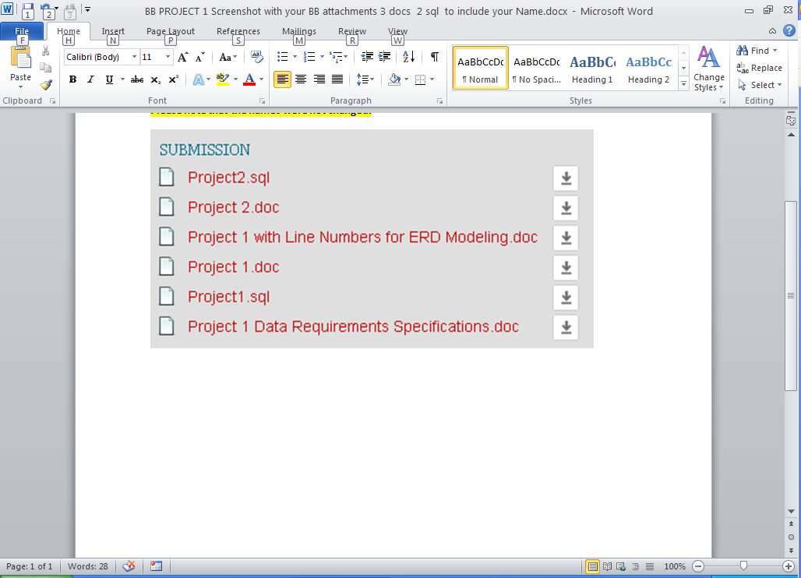

**Project 1 with Line Numbers for ERD Modeling.doc**

**Project 1 Data Requirements Specifications.doc**

**Project 1.doc**

**Project 1.sql**

**Project 1ACCESS.sql or Project 1MSSQL.sql**

**Project 2.doc**

**Project 2.sql**